**Business Intelligence Engineer Project**

**Project Title:** Student Enrollment Analysis – Regional Community College

**Prepared by:** Dr Lamia Ghozy

**Introduction**

This project demonstrates the application of **AWS QuickSight, Q, and BI engineering practices** to analyze student enrollment and satisfaction data from a regional community college. The goal of the analysis was to identify actionable strategies for improving professor evaluations and student satisfaction while maintaining cost efficiency.

The project deliverables are structured to showcase the **full BI workflow**—from dataset preparation to advanced scenario analysis and data storytelling—highlighting technical proficiency and the ability to translate data into **business-relevant insights**.

**Deliverables**

**The following components are included in this submission:**

1. **Dataset Field Names** – Complete list of dataset fields used in analysis.
2. **Dataset Refresh Schedule** – Configured refresh schedule to ensure data accuracy and currency.
3. **Calculated Field (Student Type)** – Formula used to segment Youth vs. Adult Continuing Education students.
4. **Analysis Visuals** – Custom visuals exploring professor evaluations, course costs, and satisfaction trends.
5. **Named Entities in Topic** – Defined entities enabling natural language querying.
6. **Verified Answers in Topic** – Curated list of validated Q&A outputs for reliable insights.
7. **Dashboard** – Interactive Student Enrollment Dashboard consolidating key KPIs.
8. **Scenario Analysis** – Multi-step reasoning process addressing the challenge of improving satisfaction without increasing costs.
9. **Data Story** – Full narrative combining visuals and written insights, with recommendations and conclusions.
10. **Resource Listings** – Comprehensive record of all datasets, analyses, dashboards, topics, and scenarios created.

**Professional Approach**

Each component has been carefully designed, documented, and labelled to ensure **clarity, reproducibility, and alignment with best practices in business intelligence**. Beyond fulfilling project requirements, the analysis emphasises **strategic decision-making** by:

* Identifying cost-effective courses with high satisfaction.
* Highlighting high-performing professors and replicable teaching practices.
* Providing actionable recommendations to balance academic quality with financial responsibility.

**Conclusion**

This project illustrates not only technical expertise with AWS BI tools but also the ability to frame insights in a **business context** suitable for executive decision-making. The methodology and presentation are aligned with **professional consulting standards**, making this project equally relevant as a portfolio piece and as a real-world business case study.

**1-List of Dataset Field Names:**

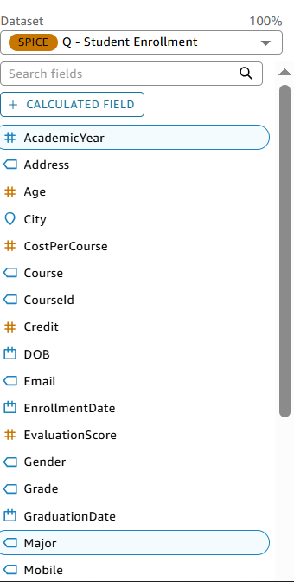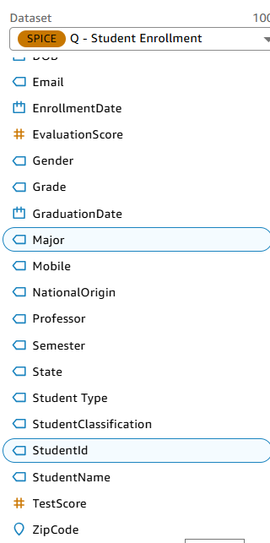

**2-Dataset Refresh Schedule:**

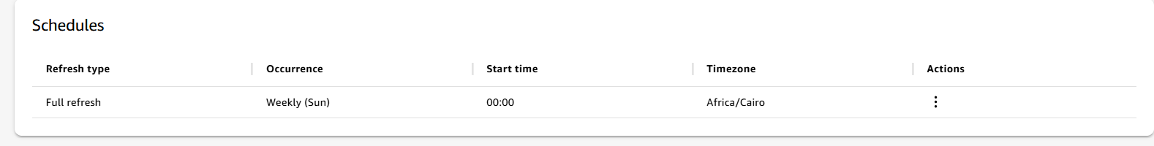

* **3-Student Type calculated field formula:**

**Calculated Formula:   
ifelse({Age} < 30, "Youth", "Adult Continuing Education"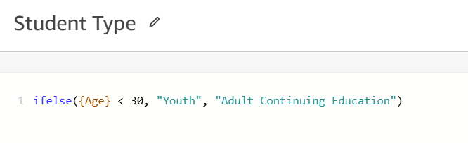)**

**4- Visuals of the Analysis:**

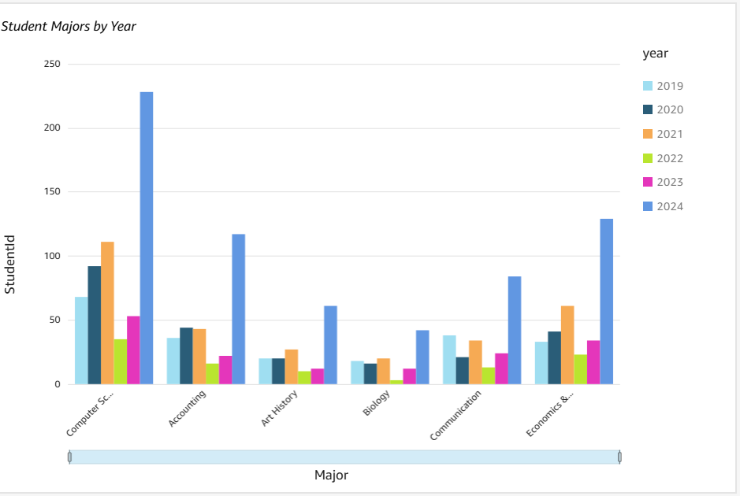**Visual 1: Student Majors by Year**

**Visual 2: Proportion of Student Types**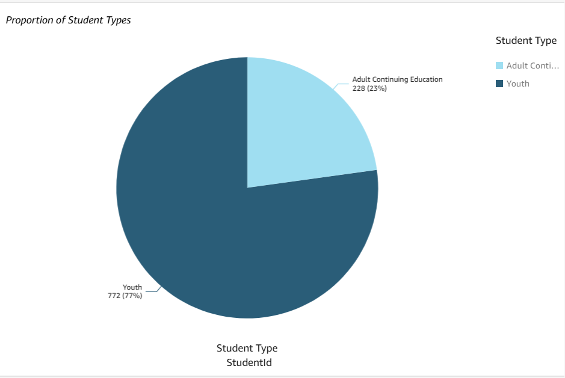

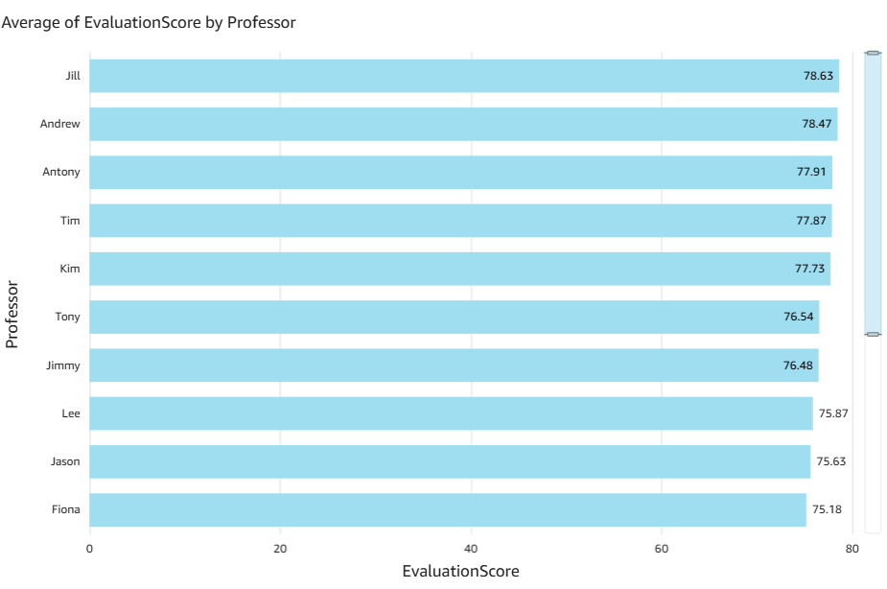**Visual 3: Average of Evaluation Score by Professor**

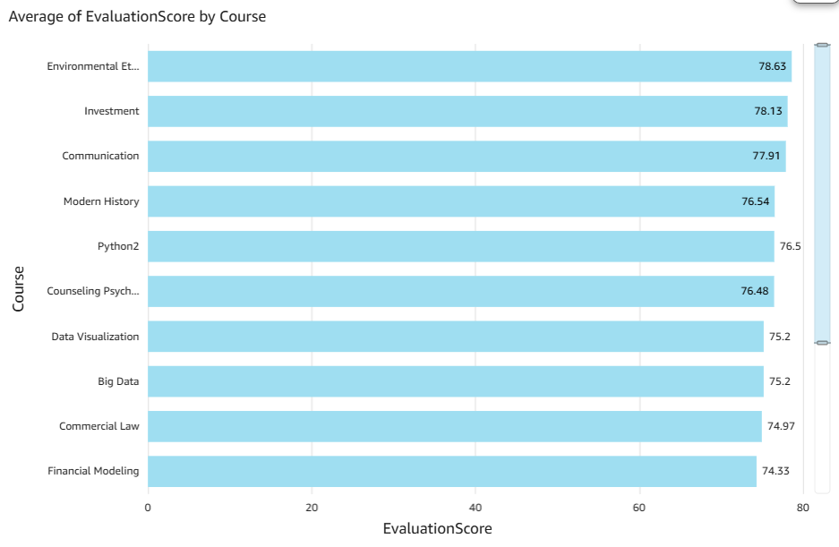**Visual 4: Average of Evaluation Score by Course**

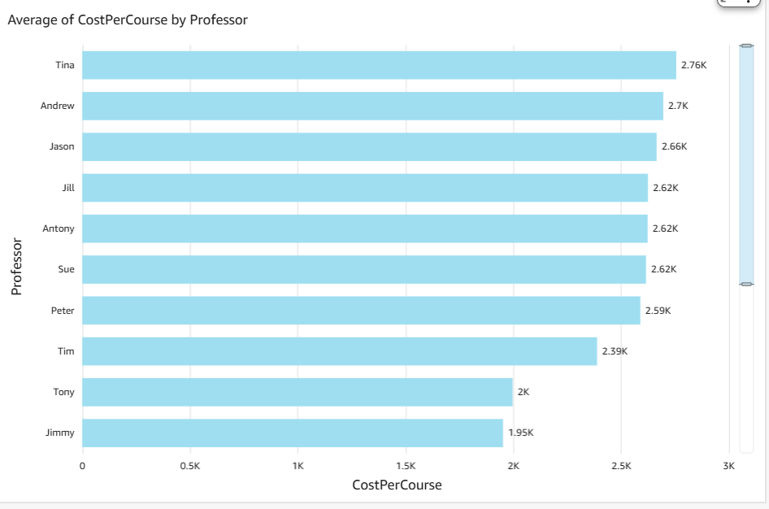**Visual 5: Average Cost per Course by Professor**

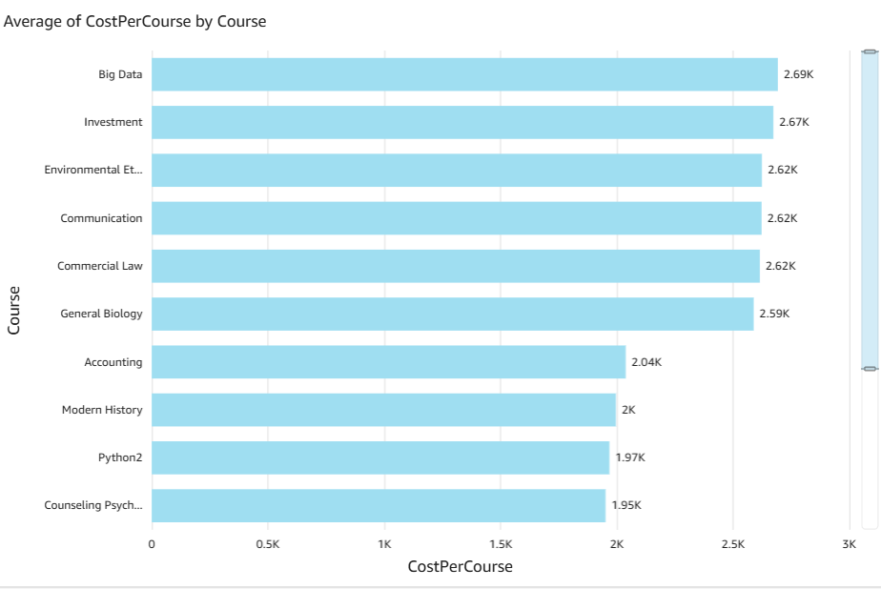**Visual 6: Average Cost per Course by Course**

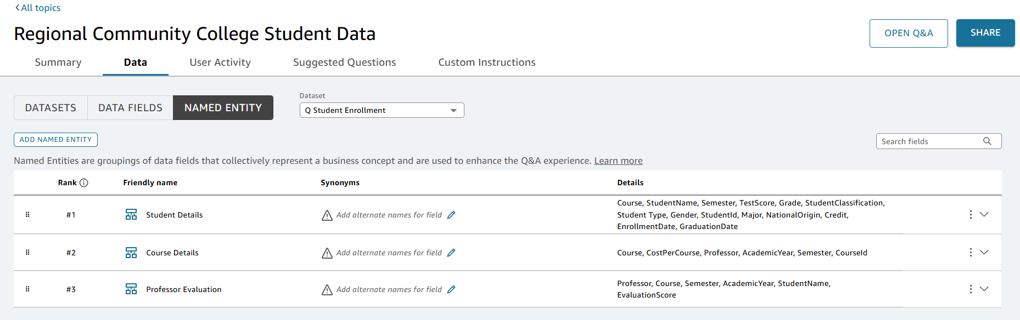**5- Names Entities in the Analysis:**

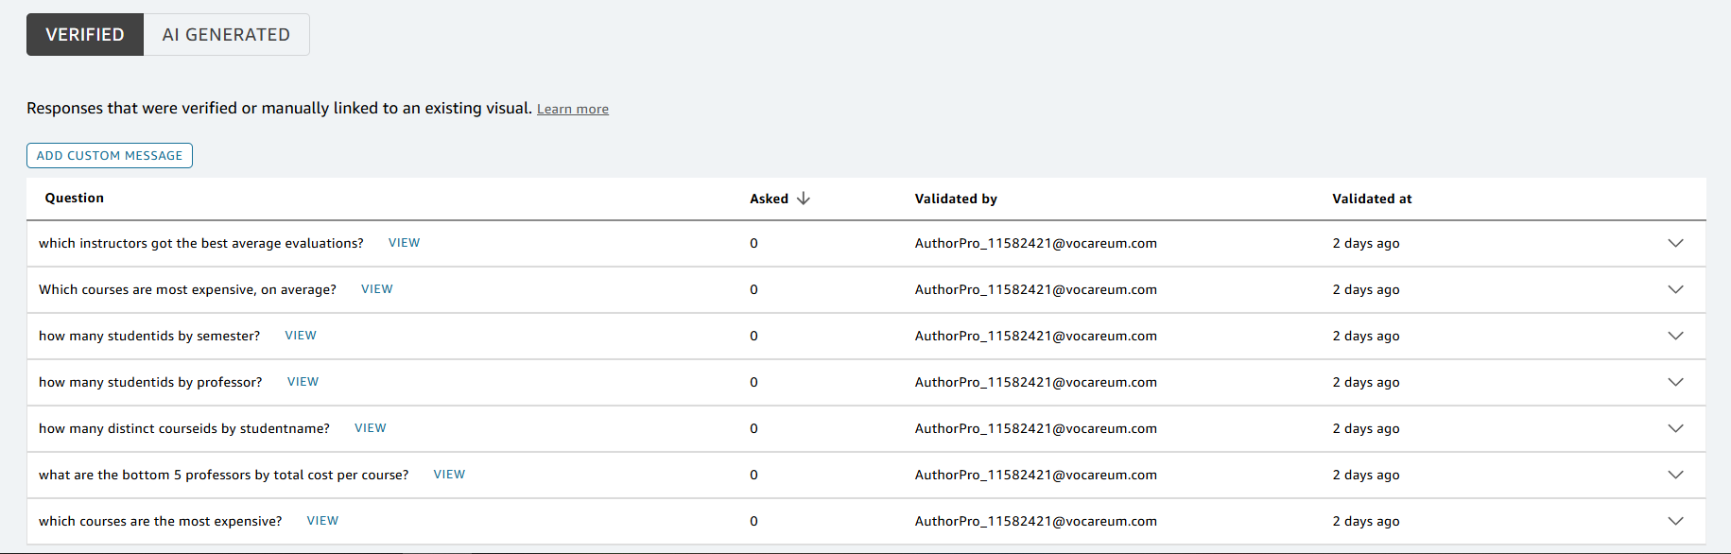**6- List of Verified Answers in the Analysis:**

**7- The Dashboard:**

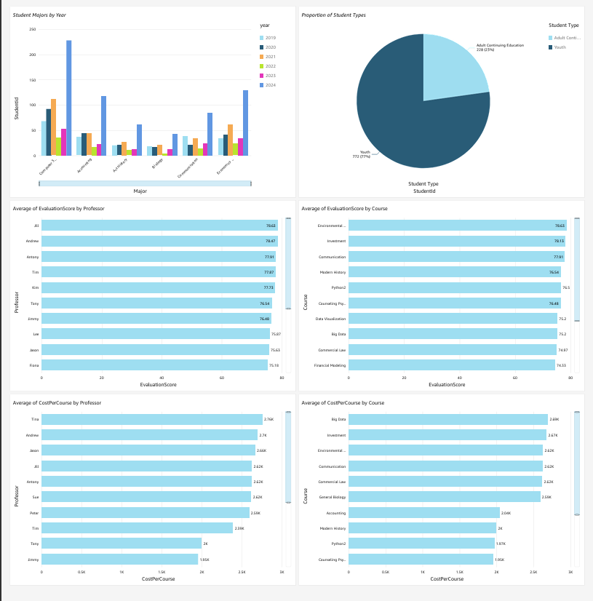

**8-The Scenario, The starter question and the follow-up questions in The Thread:**

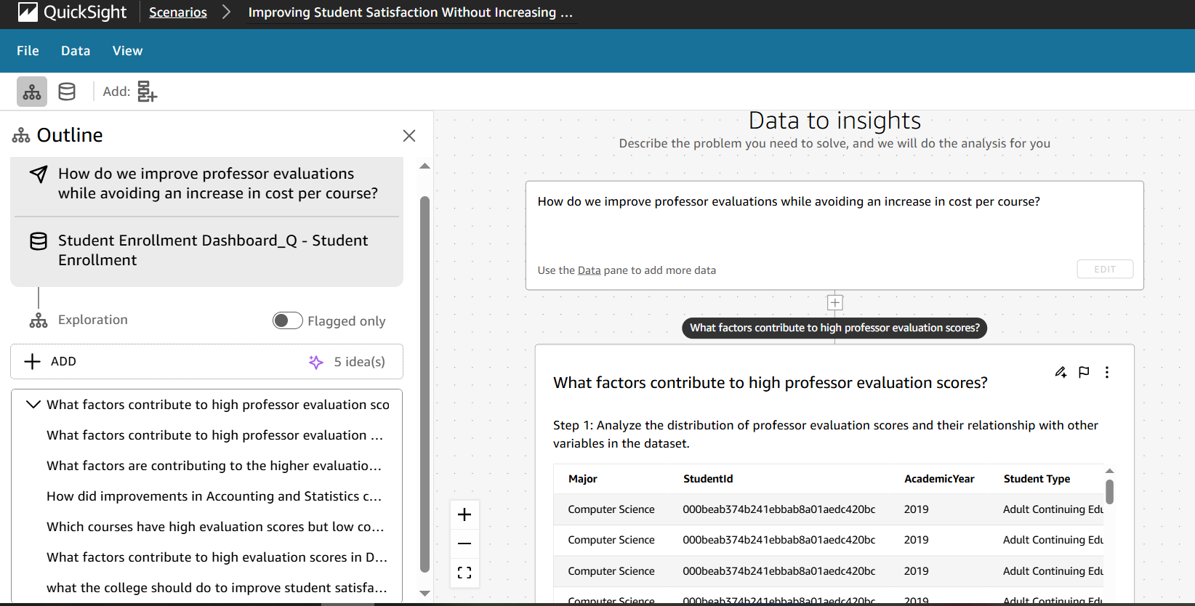

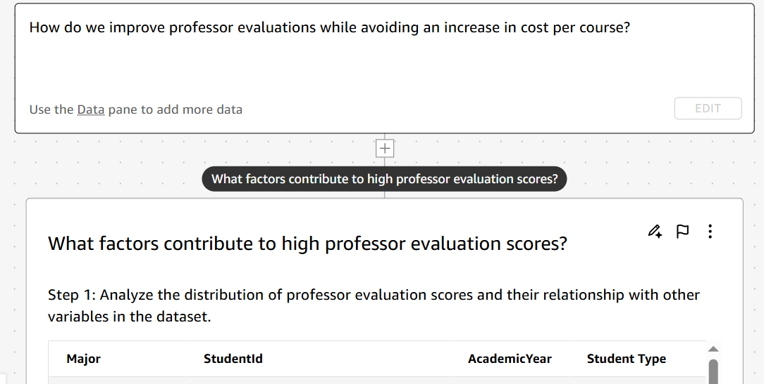

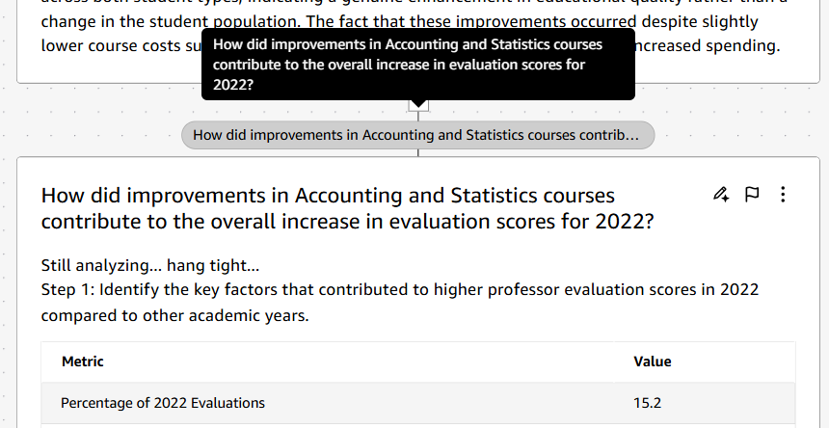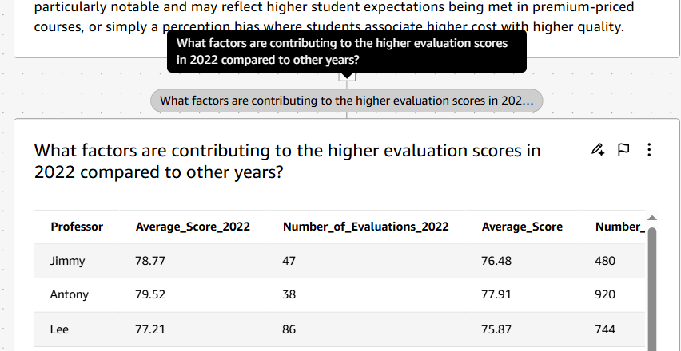

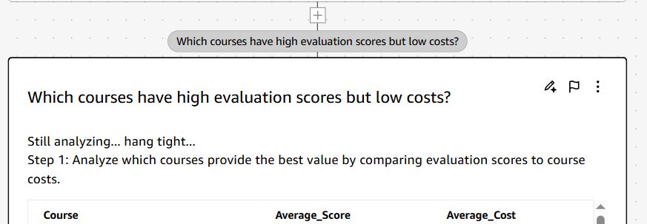

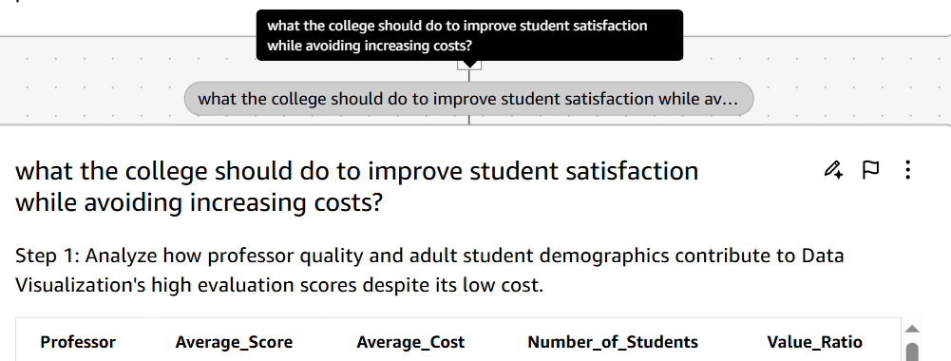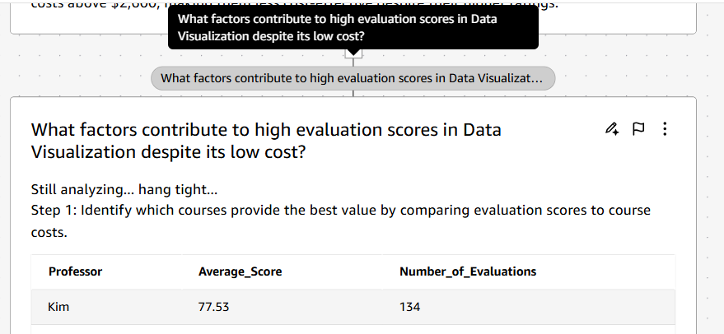

## **Scenario Analysis**

**Business Challenge:**  
The institution seeks to improve professor evaluation scores while maintaining cost efficiency. The central question guiding this analysis is:

**“How can professor performance and student satisfaction be enhanced without increasing cost per course?”**

### Analytical Thread

1. **What factors contribute to high professor evaluation scores?**  
   This question identifies the key teaching practices, course design elements, and professor attributes most strongly associated with positive student outcomes. Understanding these drivers forms the foundation for scalable improvements.
2. **What factors contributed to the higher evaluation scores in 2022 compared to previous years?**  
   By examining year-over-year performance, the analysis isolates institutional changes or pedagogical innovations that delivered measurable improvements. This provides evidence for replicating recent successes.
3. **How did improvements in Accounting and Statistics courses contribute to the overall increase in evaluation scores for 2022?**  
   Focusing at the subject level highlights how targeted improvements in specific disciplines can impact overall institutional performance. This allows decision-makers to identify “leverage points” where investment yields the highest returns.
4. **Which courses achieve high evaluation scores while maintaining low costs?**  
   This step identifies courses that maximize the value ratio (student satisfaction per dollar spent). These cost-effective success stories form the blueprint for replication and scaling across the curriculum.
5. **What factors explain the strong evaluation scores in Data Visualization despite its low cost?**  
   This case study demonstrates how exceptional results can be achieved without proportional increases in expenditure. Identifying the practices behind this outlier helps inform broader efficiency strategies.
6. **What should the college do to improve student satisfaction while avoiding increased costs?**  
   The final synthesis question consolidates insights into a set of actionable, cost-neutral recommendations for institutional leaders.

### Reflection

The scenario followed a structured progression from broad inquiry (professor-level performance) to granular investigation (discipline- and course-specific drivers) before converging into actionable strategy. This approach demonstrates how targeted analytics can uncover practical pathways for improving student satisfaction while preserving financial discipline.

### Strategic Recommendation

To enhance student satisfaction without increasing costs, the institution should:

* Prioritize resource allocation toward courses that consistently deliver strong evaluations at low cost.
* Replicate and scale the teaching methods of high-performing professors.
* Leverage successful models such as Accounting, Statistics, and Data Visualization as case studies for cost-effective excellence.

This strategy balances quality improvement with fiscal responsibility, aligning with both academic and financial objectives.

**9- Data story:**

**Story Cover:   
  
Data-Driven Teaching Excellence: A Strategic Approach to Faculty Evaluations**

**Prepared by: Dr. Lamia Ghozy**

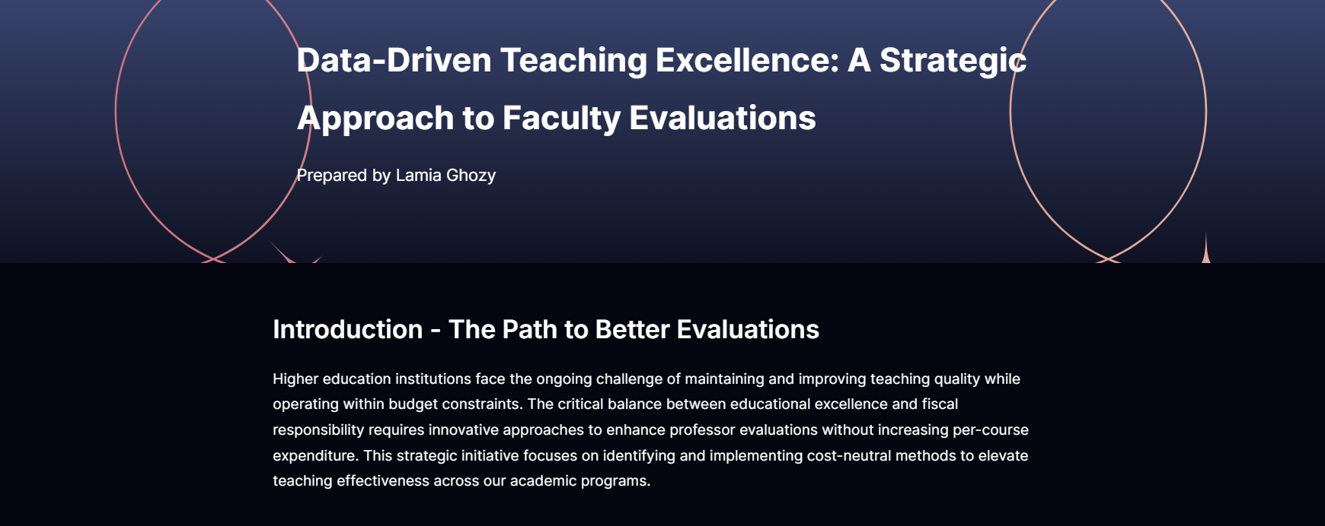

**Page 1:**

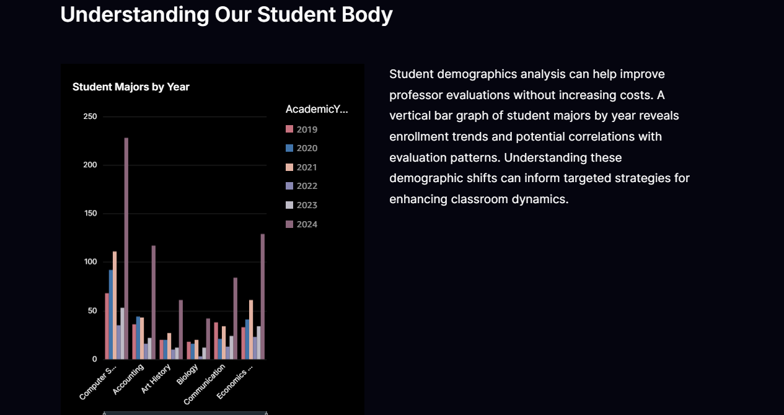

**Page 2:  
  
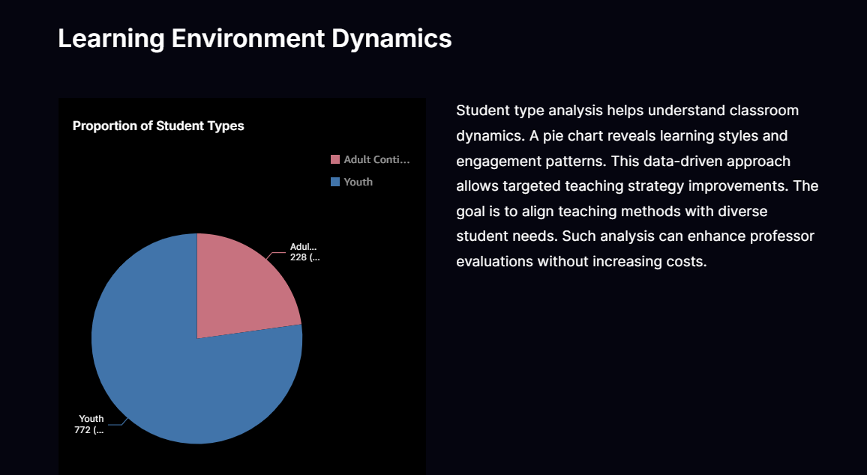**

**Page 3:**

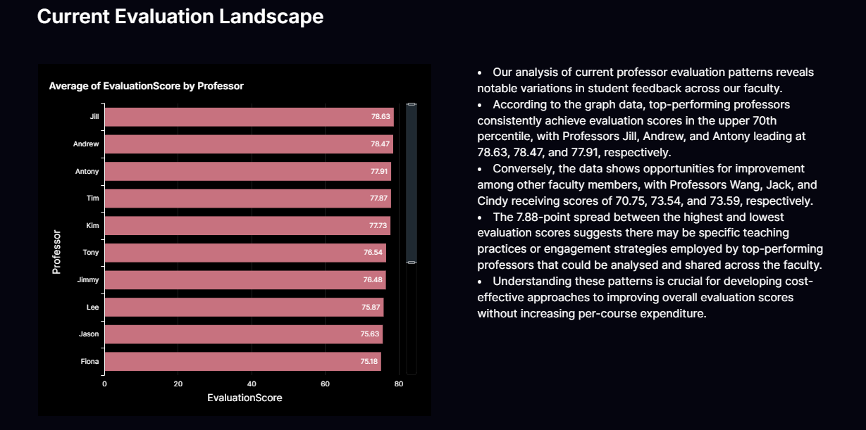

**Page 4:**

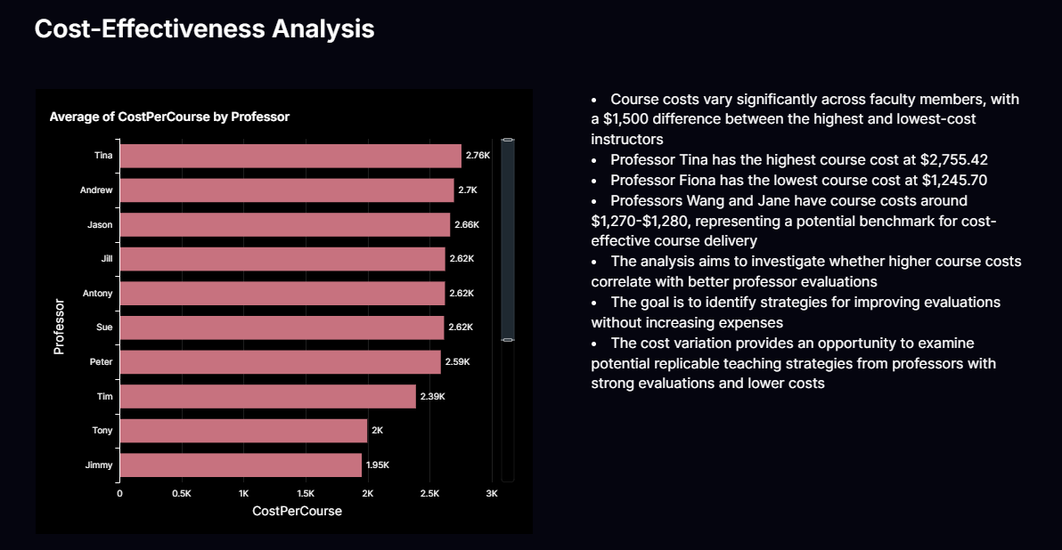

**Page 5:**

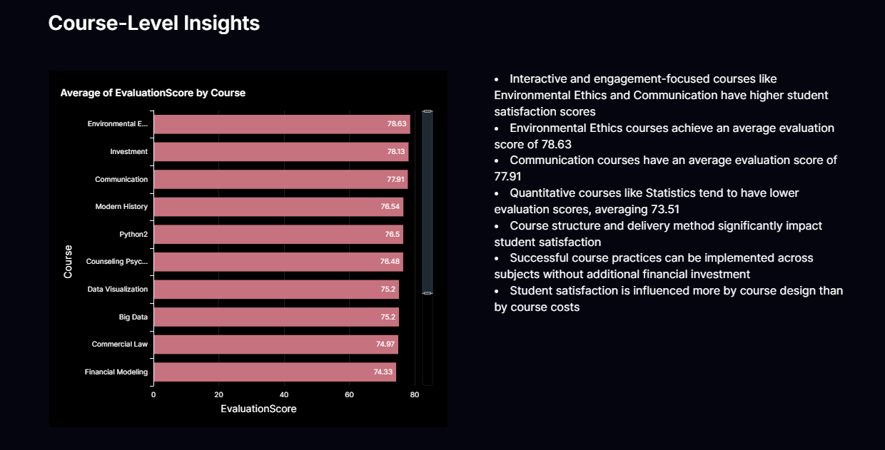

**Page 6:**

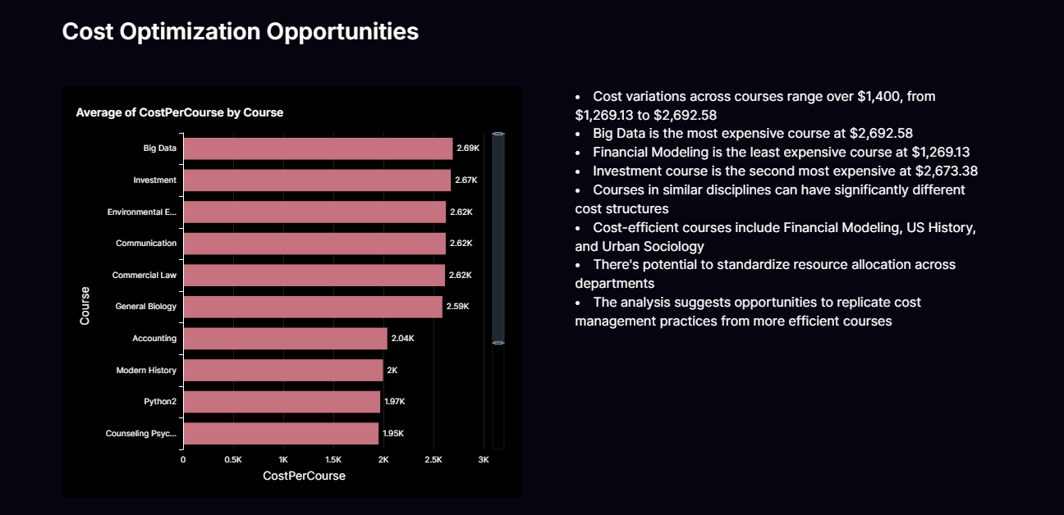

**Page 7:**

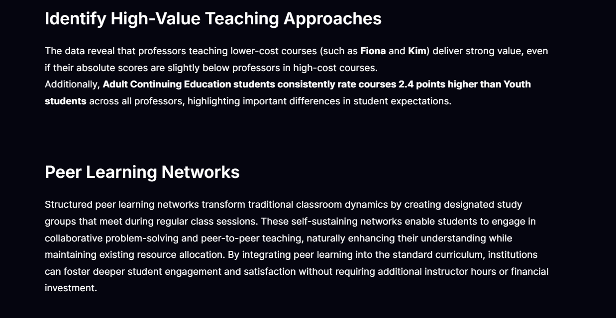

**Page 8 (part A):**

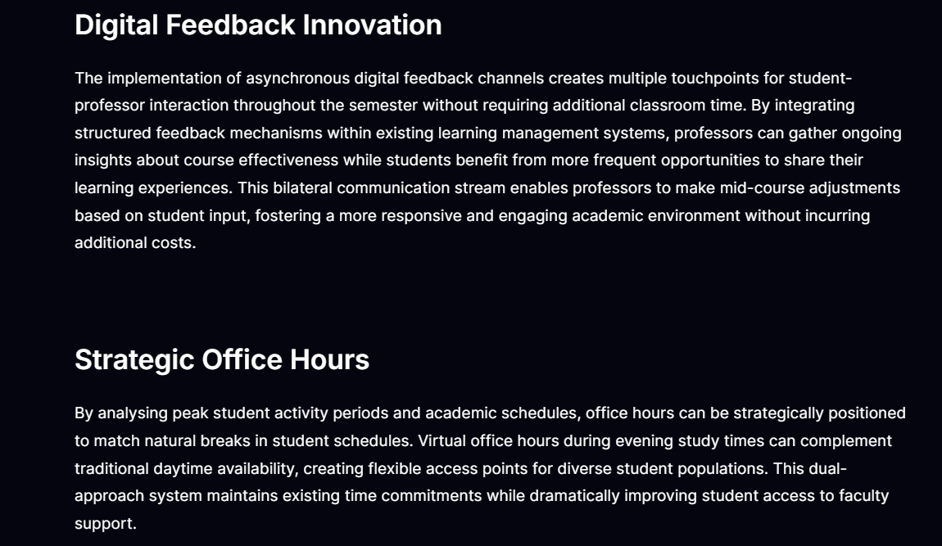

**Page 8 (part B):**

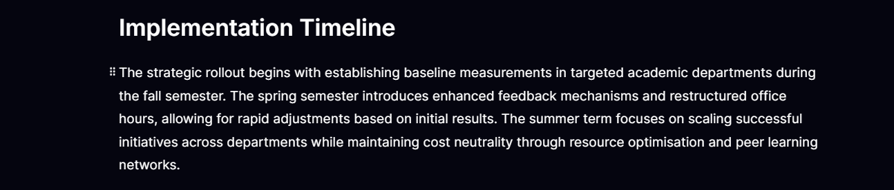

**Page 9 (part A):**

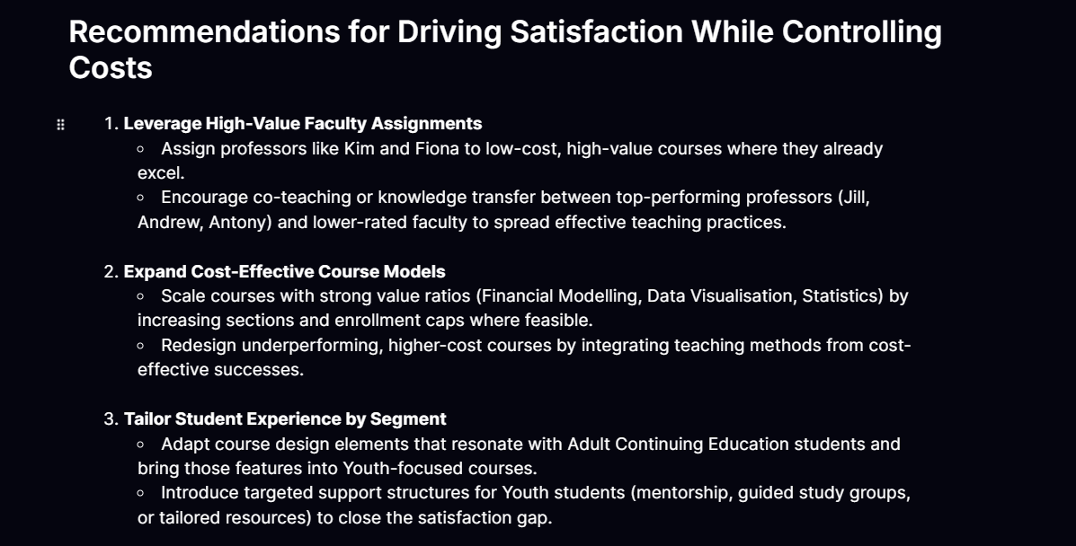

**Page 9 (part B):**

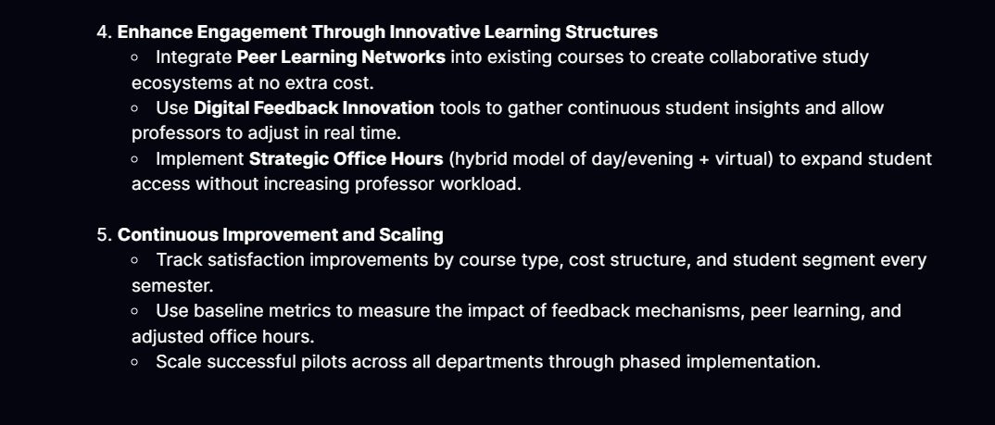

**Page 10:**

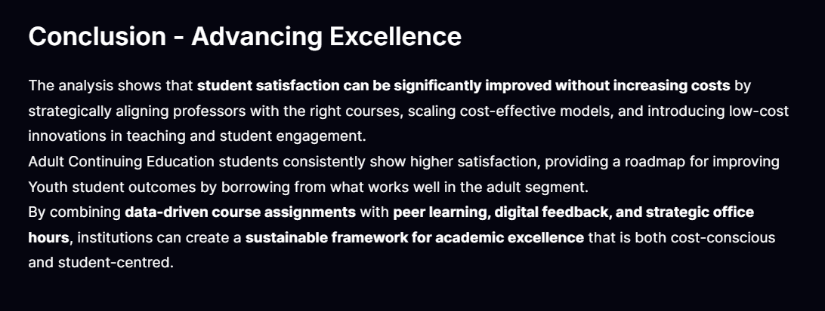

**10- Created Resources:**

**Datasets:** Q - Student Enrollment.

**Analyses:** Q – Student Enrollment

**Dashboards:** Student Enrollment

**Topics:** Regional Community College Student Data

**Scenarios:** Improving Student Satisfaction without Increasing Costs

1. **Datasets:** Q - Student Enrollment

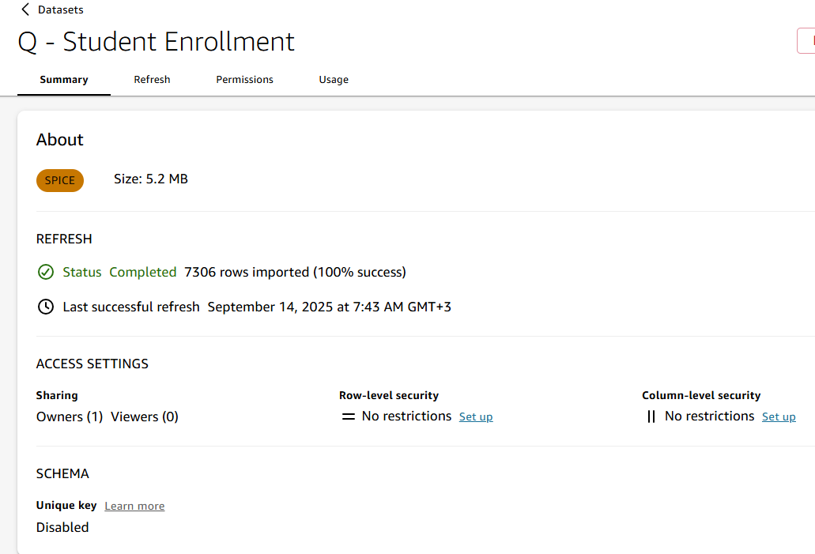

1. **Analyses:** Q – Student Enrollment

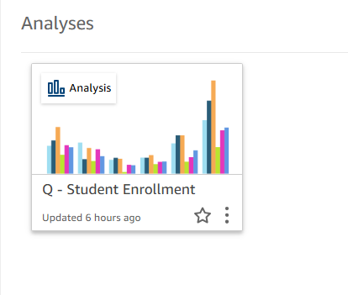

1. **Dashboards:** Student Enrollment

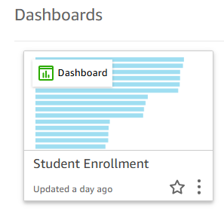

1. **Topics:** Regional Community College Student Data

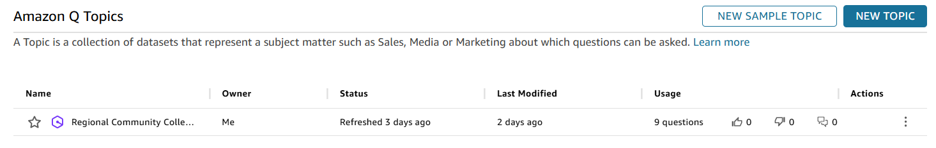

1. 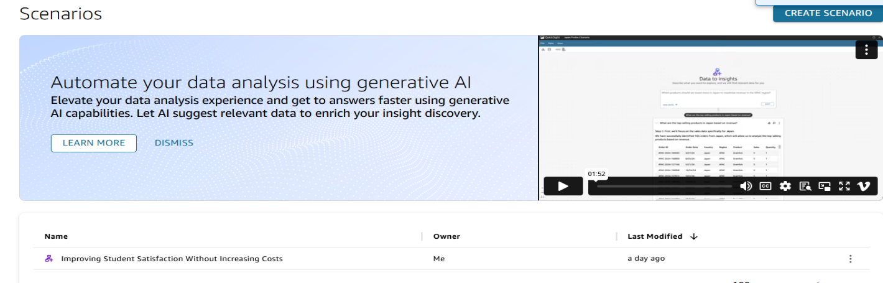**Scenarios:** Improving Student Satisfaction Without Increasing Costs

## 

## **Final Deliverables**

**This project highlights a full spectrum of Business Intelligence and Data Storytelling capabilities using Amazon QuickSight:**

* **Data Preparation & Modeling**
  + Dataset structuring, enrichment, and creation of calculated fields (e.g., *Student Type*).
  + Configured dataset refresh schedules to ensure data accuracy and timeliness.
* **Data Visualization & Dashboard Design**
  + Built interactive dashboards with multiple visual types (bar, line, heatmaps, etc.).
  + Applied best practices in labeling, formatting, and visual clarity for business audiences.
* **Advanced BI Features**
  + Developed *Topics* with named entities and verified answers for natural-language queries.
  + Designed *Scenarios* with multi-step analytical reasoning, connecting data exploration to business strategy.
  + Crafted a *Data Story* to communicate insights effectively through visuals, narrative, and actionable recommendations.
* **Business Communication**
  + Synthesized technical findings into executive-ready insights.
  + Framed analysis around strategic goals: improving professor evaluations, enhancing student satisfaction, and optimizing cost efficiency.

## **Closing Note**

This project demonstrates how Business Intelligence can transform raw educational data into **strategic insights** that improve student satisfaction while optimizing costs. The approach reflects not only technical execution but also **business-oriented problem solving**—a skill set directly transferable to real-world organizational challenges.